- What is a microprocessor?
A programmable IC that fetches, decodes, and executes instructions.
- Which was the first microprocessor?
Intel 4004, a 4-bit processor released in 1971.
- Why is a microprocessor called the CPU of a computer?
It controls and processes all system operations.
- How does the ALU work?
It performs arithmetic and logic operations.
- What is the role of the control unit?
It generates control signals to coordinate operations.
- Which buses connect CPU to memory?
Address, data, and control buses.
- Why is program counter needed?
It holds the next instruction address.
- How does a stack help?
It stores temporary data like return addresses.
- What are the flags in 8085?
Sign, Zero, Auxiliary carry, Parity, and Carry.
- What is instruction set?
A collection of machine-level instructions.
- Which addressing modes exist in 8085?
Immediate, direct, register, indirect, and implied.
- Why is assembly language useful?
It gives low-level hardware control with mnemonics.
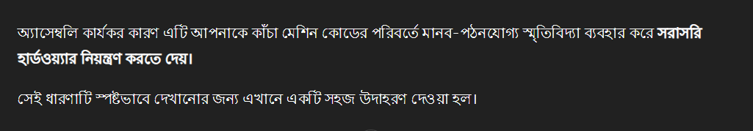
- How does assembler work?
It translates mnemonics into machine code.
- What is opcode?
It specifies the operation to be performed.
- Which registers are in 8086?
General, segment, pointer, index, and flag registers.
- Why does 8086 use segmentation?
To access 1MB memory using 20-bit addressing.
- How many bits are in 8085’s data bus?
It has an 8-bit data bus.
- What is pipelining?
Overlapping instruction execution phases.
- Why is instruction queue in 8086?
It prefetches instructions to speed execution.
- What is difference between RISC and CISC?
RISC has simple, fast instructions; CISC has complex ones.
- Which is faster: register or memory access?
Registers are much faster.
- What does instruction decoder do?
It interprets opcodes and signals operations.
- Why are interrupts used?
They handle urgent events without polling.
- How does maskable differ from non-maskable interrupt?
Maskable can be disabled; non-maskable cannot.
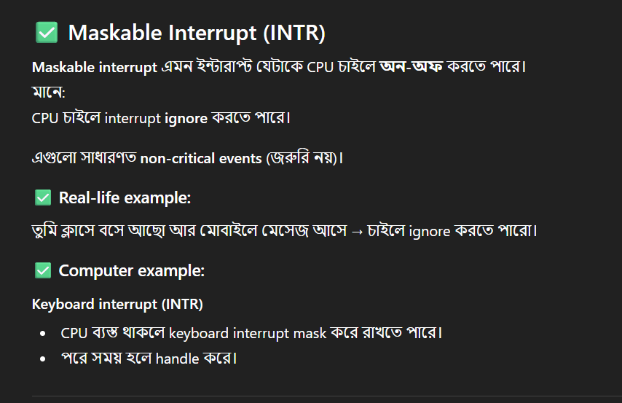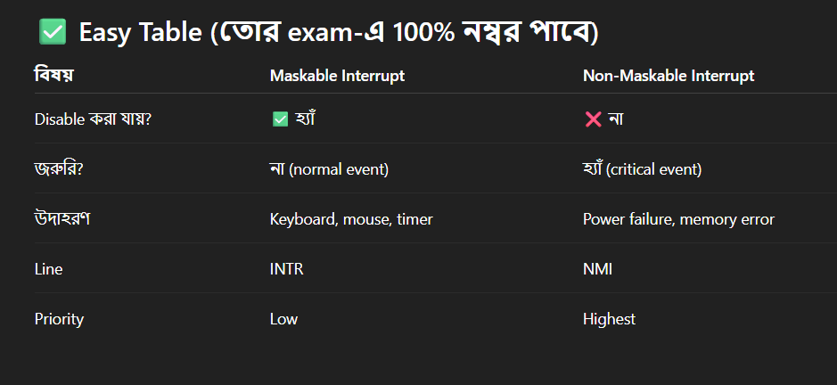
- Which is the highest priority interrupt in 8085?
TRAP, a non-maskable interrupt.
- Why are flags needed in ALU?
They show result conditions like zero or carry.
- How many address lines in 8085?
16 lines for 64KB memory.
- What is stack pointer?
A 16-bit register pointing to top of stack.
- Which memory is cache?
SRAM between CPU and RAM.
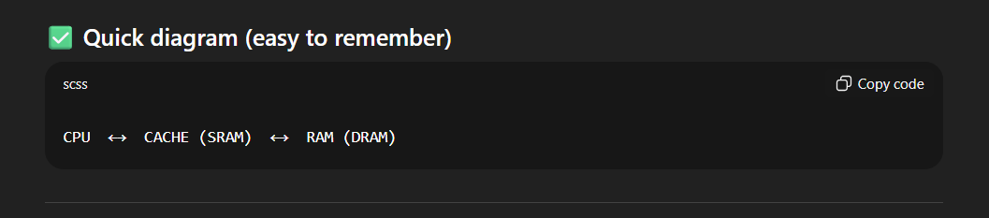
- Why is clock signal needed?
It synchronizes CPU operations.
- What is machine cycle?
Time for one fetch/read/write operation.
- Which is faster: SRAM or DRAM?
SRAM is faster but expensive.
- Why is ALE signal in 8085?
It separates multiplexed address/data lines.
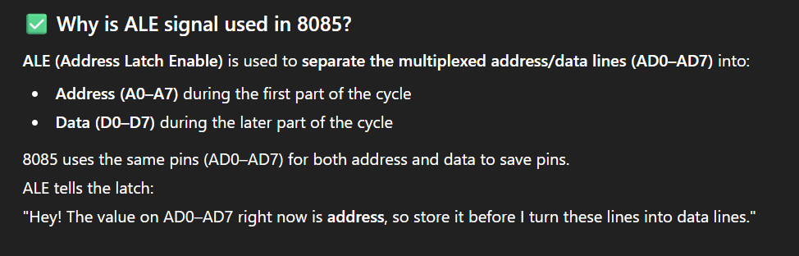
- How many instructions in 8085?
74 instructions, 246 opcodes.
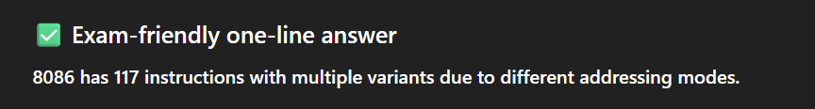
- What is difference between CALL and JUMP?
CALL saves return address; JUMP does not.
- Which instruction clears accumulator?
XRA A sets accumulator to 0.
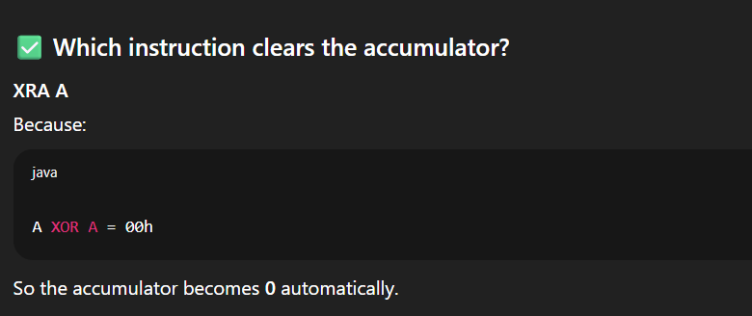
- Why are macros used?
They replace repetitive code with one definition.
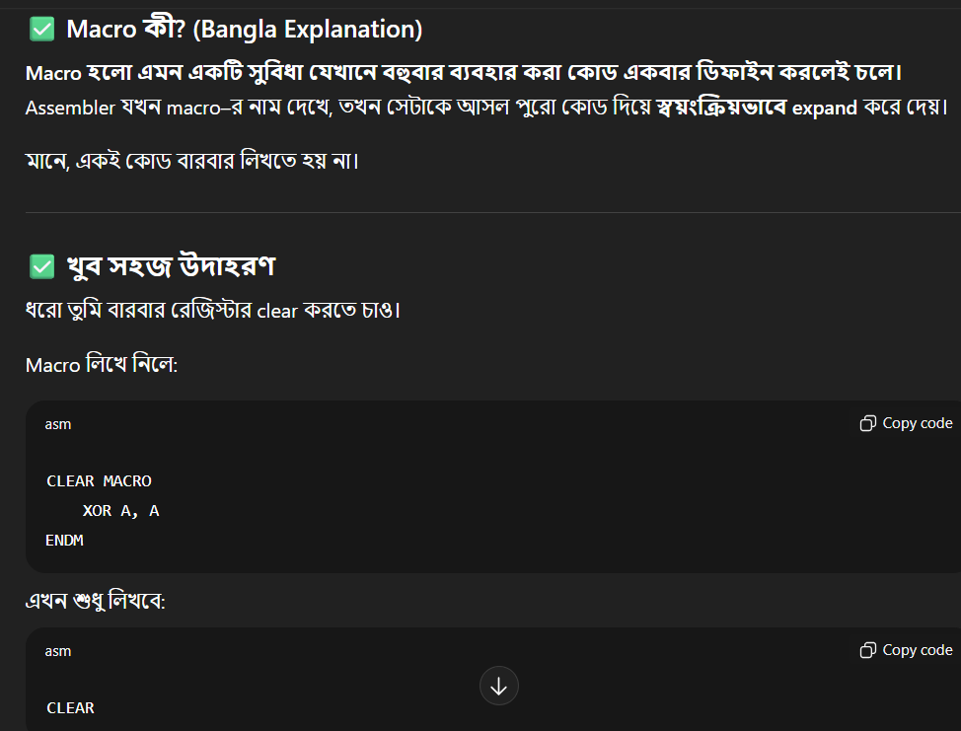
- How are subroutines defined?
Small reusable code blocks called by CALL.
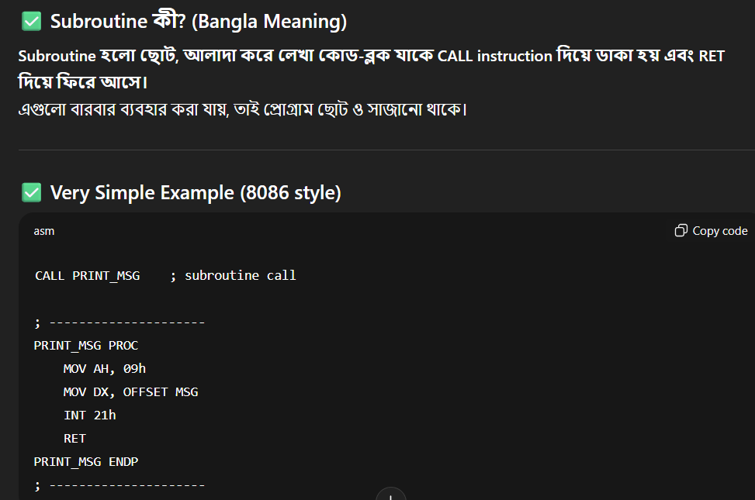
- Which instruction checks zero flag?
JZ checks if result is zero.
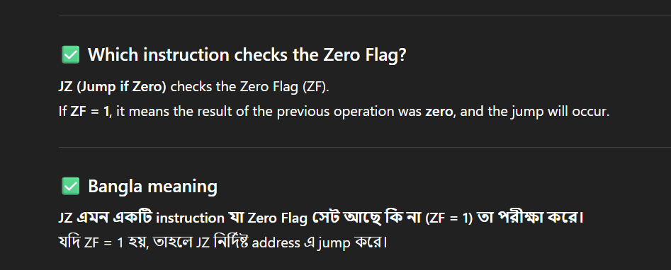
- Why use SIM instruction?
To mask interrupts and set serial output.
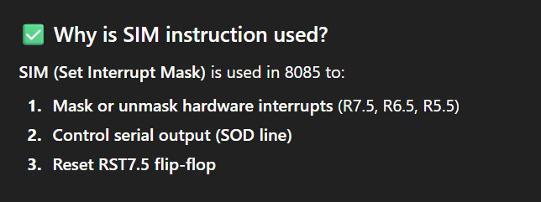
- What do IN/OUT instructions do?
They transfer data between CPU and I/O ports.
- Why are multiplexed buses used?
To reduce chip pin count.
- What is DMA?
Direct device-to-memory data transfer.
- Which signal indicates read?
RD̅ indicates memory or I/O read.

- What is T-state?
One clock period of operation.
- Which are segment registers in 8086?
CS, DS, SS, and ES.
- Which register pair points memory in 8085?
HL register pair.
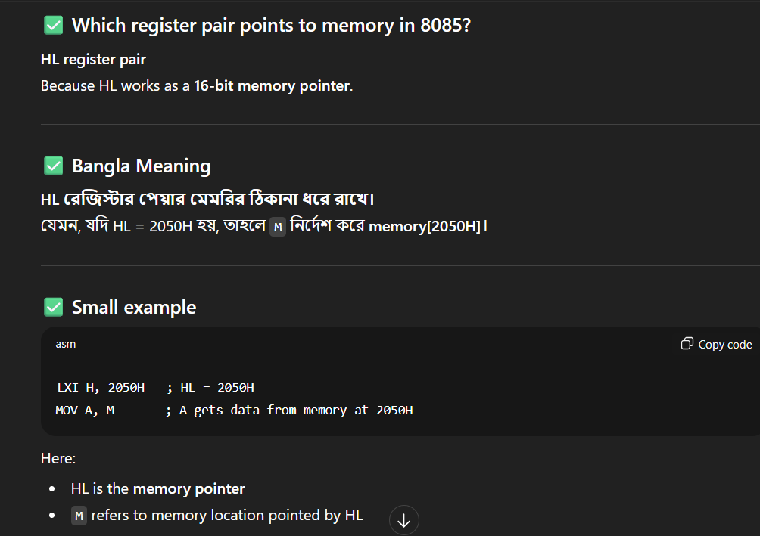
- Why are logical instructions needed?
For AND, OR, XOR, shifts, complements.
- What is difference between immediate and direct addressing?
Immediate has value; direct has memory address.
- Which instruction halts CPU?
HLT stops execution.
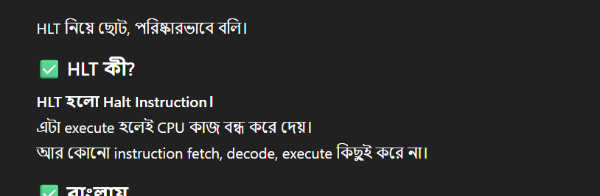
- Why is segmentation beneficial?
Supports modular programming and large memory.
- How does microprocessor differ from microcontroller?
Processor needs peripherals; controller has them built-in.
- What is signed vs unsigned numbers?
Signed include negatives; unsigned only positives.
- Which instruction rotates accumulator?
RLC and RRC.
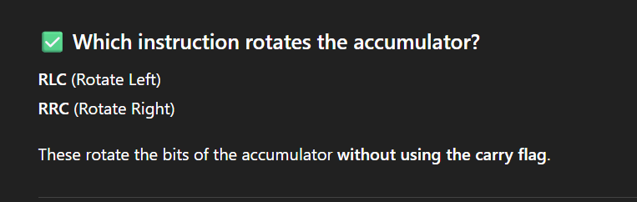
- Why are assembler directives used?
They guide assembler, not CPU.
- How are loops implemented?
With LOOP instruction and CX.
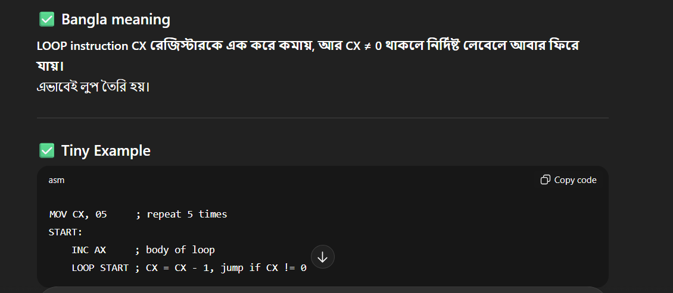
- What is near vs far jump?
Near changes IP only; far changes CS:IP.
- Why is CALL powerful?
It supports modular coding.
- Which instruction swaps data?
XCHG exchanges register contents.
- Why use pseudo-instructions?
For labels and variables.
- How does PUSH work?
SP decrements and data is stored.
- Which restores data from stack?
POP retrieves register content.
- Why segment overrides in 8086?
To access non-default segments.
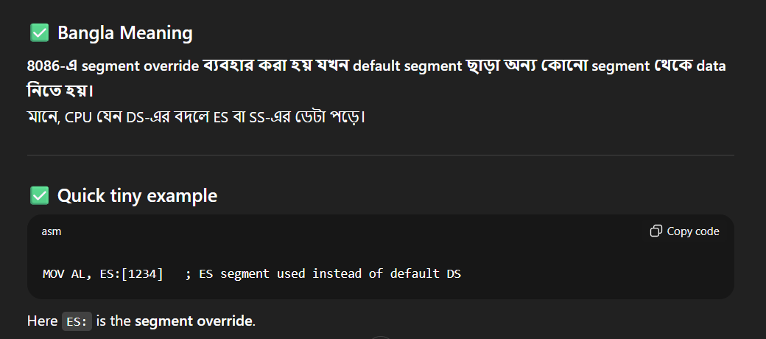
- What are software vs hardware interrupts?
Software from instructions; hardware from signals.
- Which instruction generates software interrupt?
INT n.
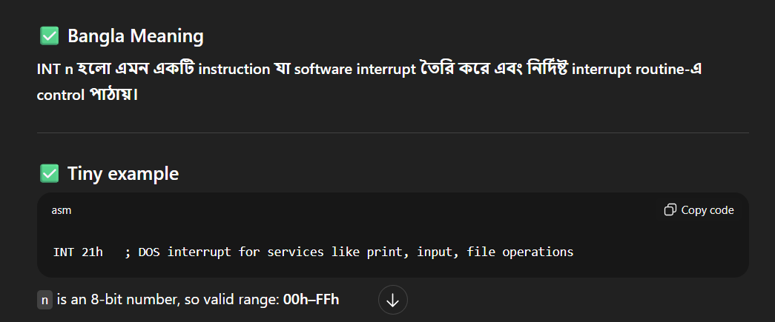
- Why priority encoder in interrupts?
To resolve multiple requests.
- What is instruction queue size in 8086?
6 bytes.
- Which signal distinguishes memory vs I/O?
IO/M̅.
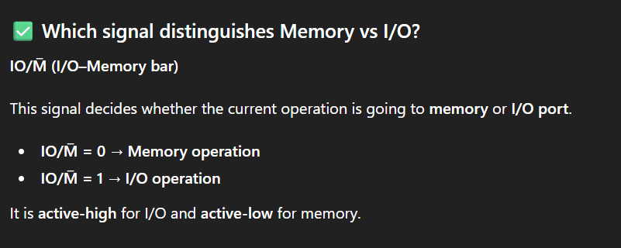
- Why parity flag?
It checks even/odd bits.
- Which instruction complements accumulator?
CMA flips all bits.
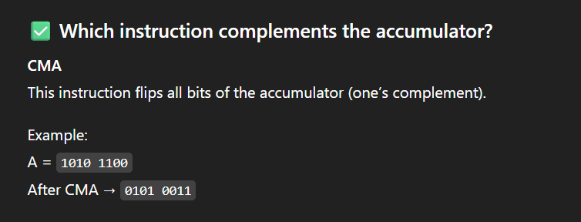
- Why use shift instructions?
For fast multiply/divide by 2.
- What is SHR vs SAR?
SHR logical; SAR arithmetic.
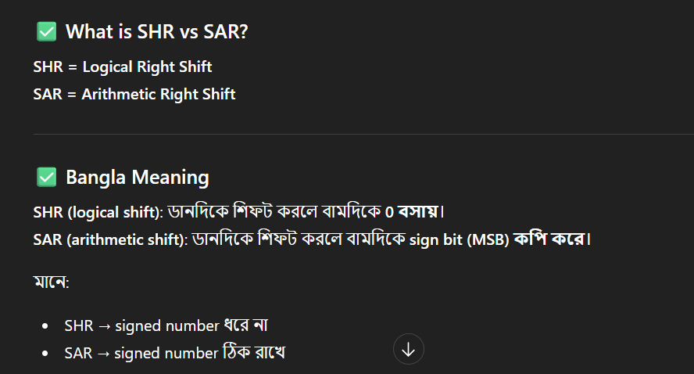
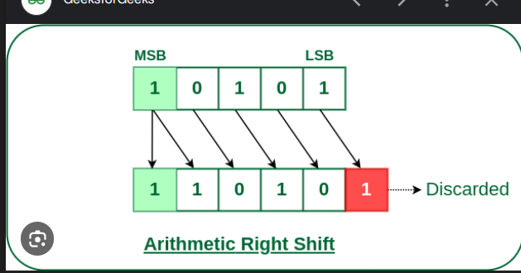
- Why interrupts faster than polling?
They avoid constant checking.
- Which register is base pointer in 8086?
BP register.
- Why overlap segments in 8086?
For memory efficiency.
- What is trap flag?
It enables single-step debugging.
- Why conditional jumps?
They branch based on flags.
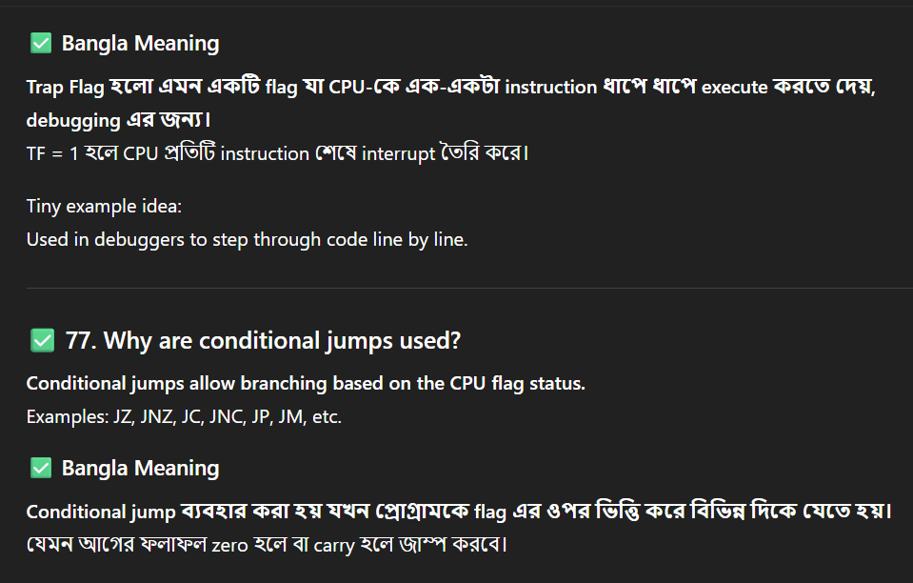
- Which instruction multiplies signed numbers?
IMUL.
- Why minimum and maximum mode in 8086?
For single or multiprocessor use.
- Which instruction divides unsigned numbers?
DIV.
- What is assembler pass-1?
It builds symbol table and checks syntax.
- What is pass-2?
It generates machine code.
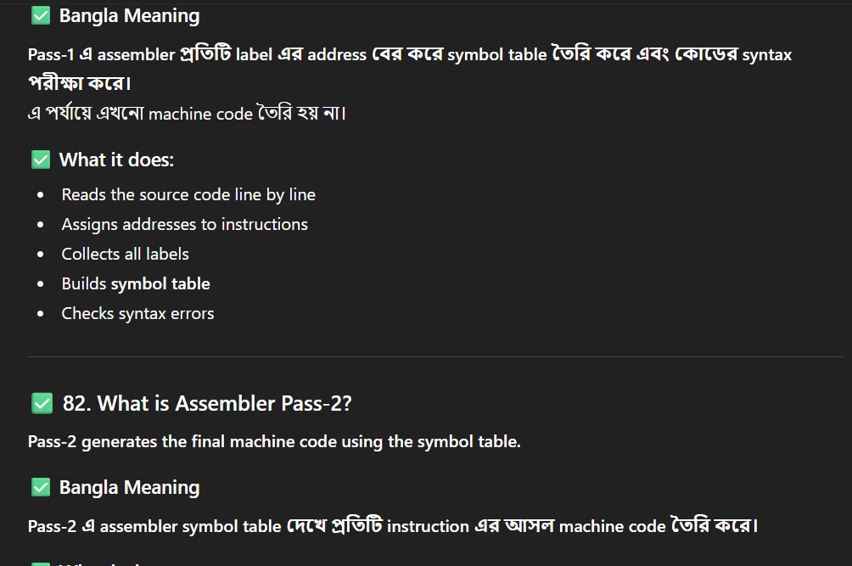
- Why are labels used in assembly?
They mark instruction addresses.
- Which register holds instruction pointer?
IP register.
- What is difference between MOV and MVI?
MOV copies register/memory; MVI loads immediate data.
- Why segment:offset addressing?
To form 20-bit address.
- What are predefined interrupts in 8086?
INT 0–4 for divide, debug, NMI, etc.
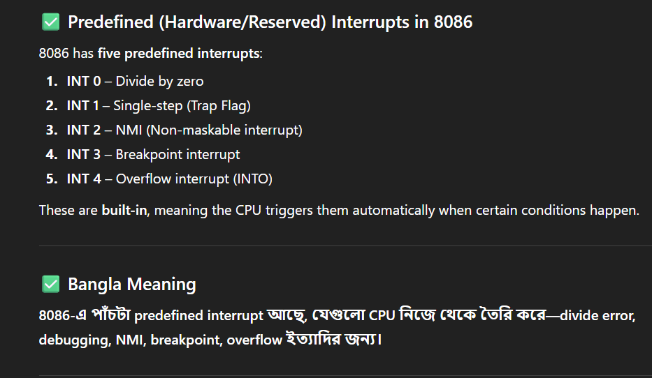
- Which flag shows overflow?
Overflow flag (OF).
- Why conditional call instructions?
They call subroutines only if flag set.
- What is difference between assembler and linker?
Assembler makes object code; linker combines modules.
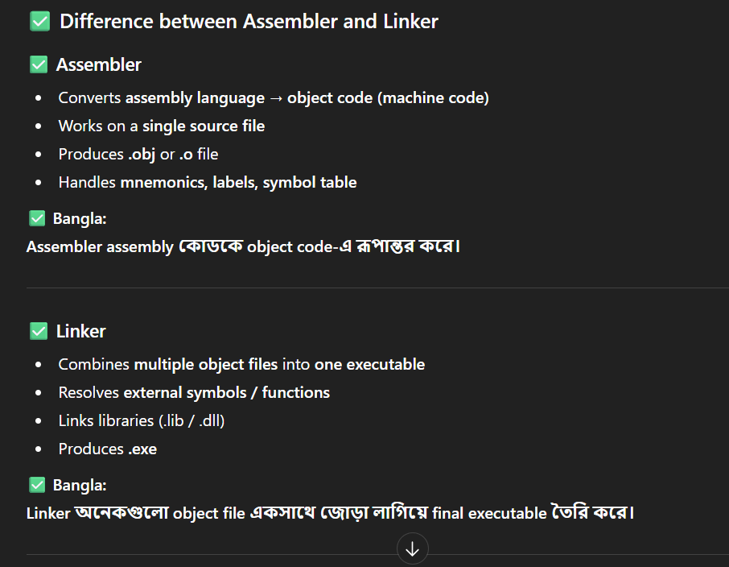
- Which instruction clears carry flag?
CLC.
- Why stack grows downward?
To avoid overlap with code/data segments.
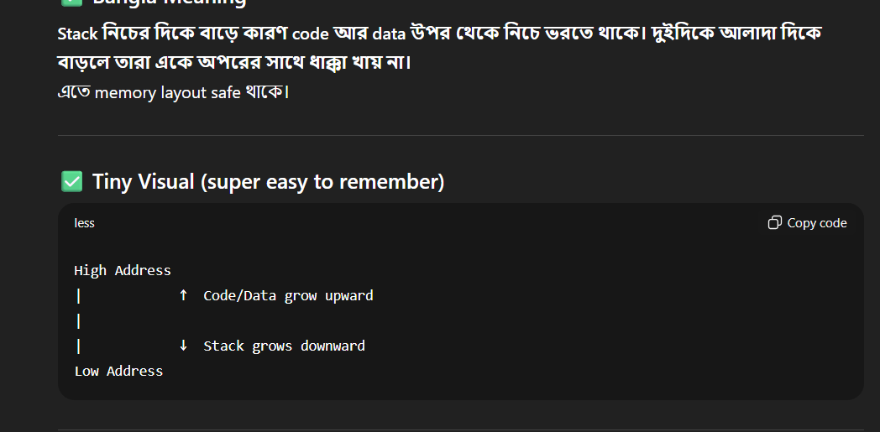
- What is difference between ORG and EQU?
ORG sets location; EQU assigns constant.
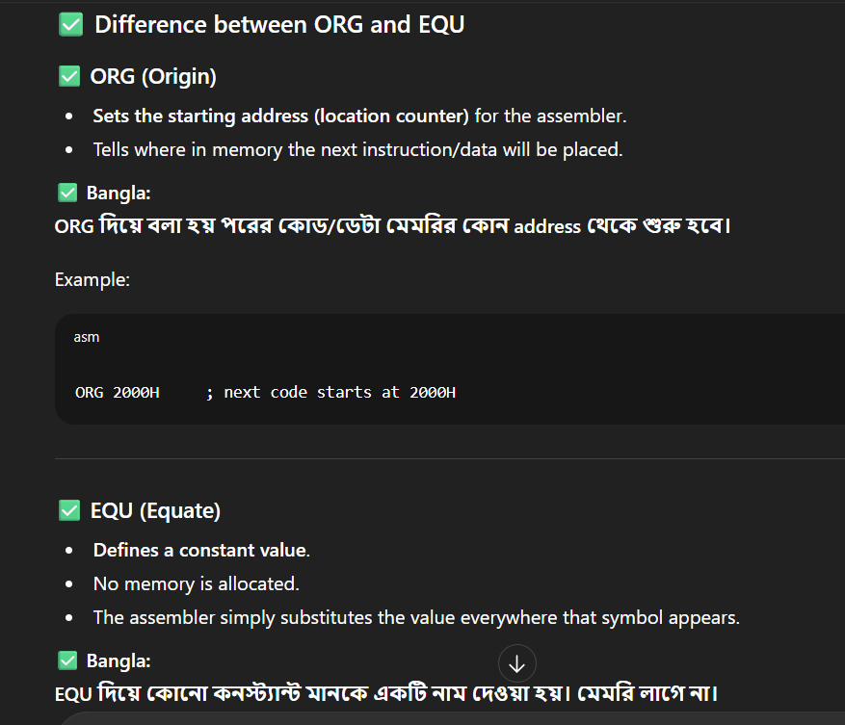
- Which instruction is no-operation?
NOP.
- Why LOOP instruction useful?
It reduces jump overhead.
- What is role of CS in 8086?
Holds code segment base address.
- Which instruction loads effective address?
LEA.
- Why test instruction used?
It performs AND without changing operands.
- What is use of XLAT?
It translates byte from lookup table
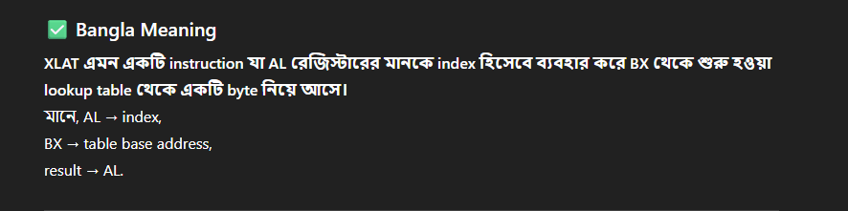
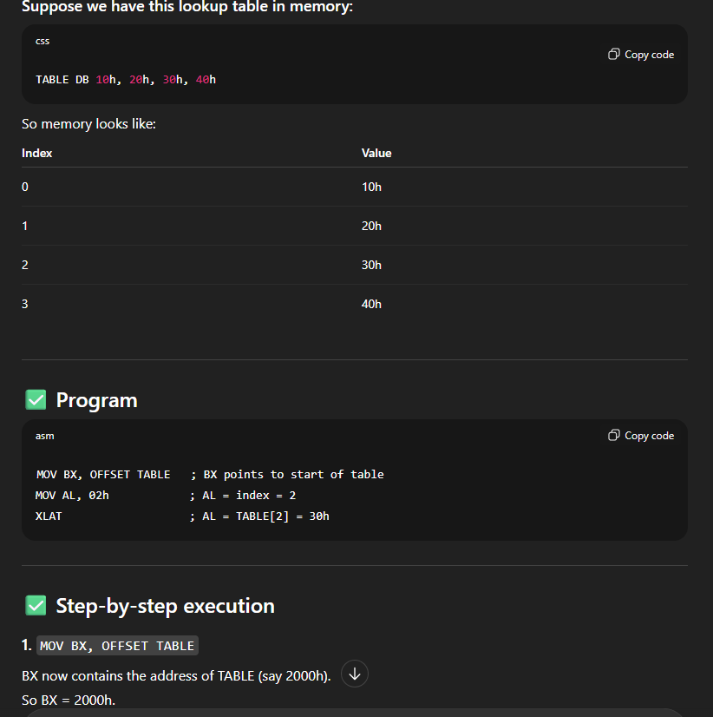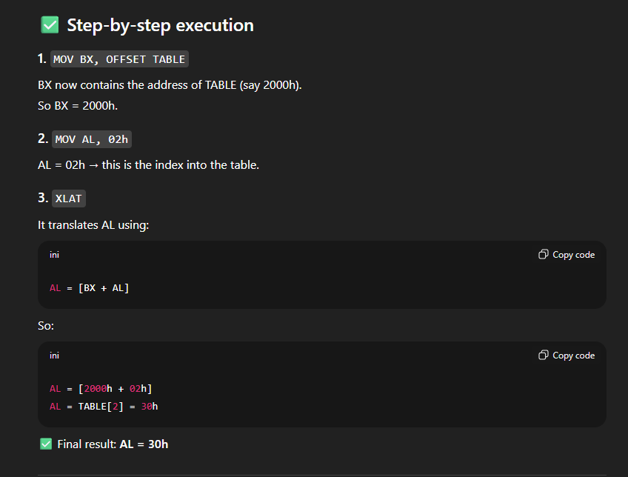
- Which instruction copies string?
MOVS copies bytes/words.
- Why direction flag important?
It decides string movement left/right.
- Which instruction scans string?
SCAS searches for byte/word.
- Why repeat prefixes used?
To repeat string instructions.
- What is difference between REP and REPE?
REP repeats always; REPE while equal.
- Which instruction compares strings?
CMPS compares two strings.
- Why use conditional assembly?
To assemble code selectively.
- What are macros vs procedures?
Macros expanded inline; procedures invoked.
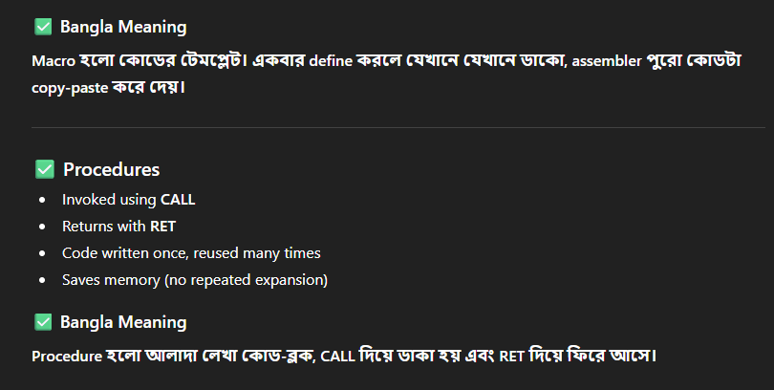
- Why modular programming important?
It improves readability and reuse.
- Which instruction returns from interrupt?
IRET.
- What is difference between CLI and STI?
CLI clears interrupts; STI enables them.
- Why are WAIT states used?
To match slow memory speed.
- What is READY signal in 8086?
It indicates peripheral readiness.
- Which pin indicates power supply in 8085?
Vcc = +5V, Vss = GND.
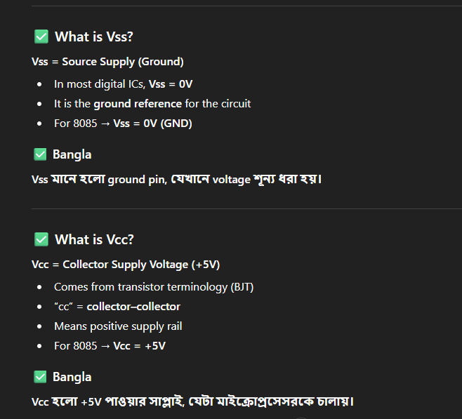
- Why multiplex address/data lines?
To save pins on IC.
- What is function of SID/SOD in 8085?
Serial input/output lines.
- Which register holds memory pointer in 8086?
SI and DI.
- Why is SS register needed?
It points to stack segment.
- What is difference between JMP and LCALL?
JMP changes control; LCALL saves return.
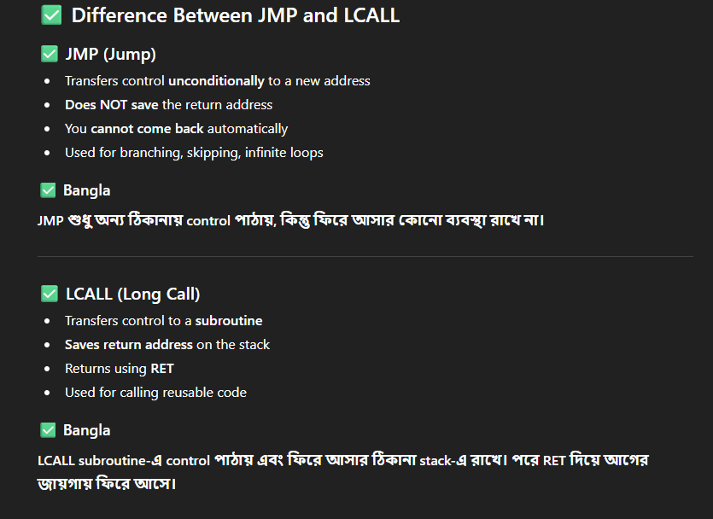
- Why PUSHF and POPF used?
To save and restore flags.
- Which instruction shifts with carry?
RCL/RCR.
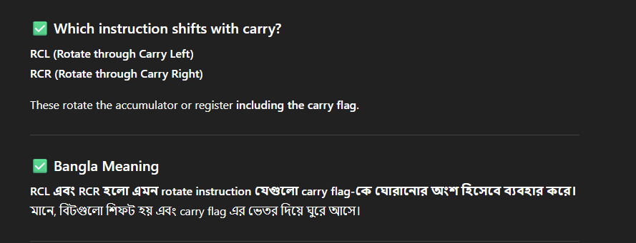

- What is role of NOP?
It wastes one cycle for timing.
- Why assembler generates listing file?
For debugging and reference.
- What is use of END directive?
It marks end of source program.
- What is microcode in processors?
It is low-level control instructions stored in control memory.
- Which pipeline hazards occur in microprocessors?
Structural, data, and control hazards.
- Why cache coherence is important?
To keep multiple cache copies consistent.
- How does virtual memory help CPUs?
It extends memory using disk storage.
- What is paging in memory systems?
Dividing memory into fixed-size pages.
- Why segmentation faults occur?
Due to invalid memory access.
- How does MMU work?
It translates virtual to physical addresses.
- Which technique improves instruction throughput?
Pipelining.
- Why branch prediction important?
To reduce pipeline stalls.
- What is microprogrammed control?
Control signals generated by microcode.
- Which addressing mode is fastest?
Register addressing.
- Why is Harvard architecture used?
It separates instruction and data buses.
- How does superscalar architecture improve performance?
By executing multiple instructions per cycle.
- What is difference between macro and micro instruction?
Macro is high-level assembly; micro is hardware-level control.
- Why stack overflow occurs?
Due to exceeding allocated stack memory.
- How does interrupt vector table work?
It holds addresses of ISRs.
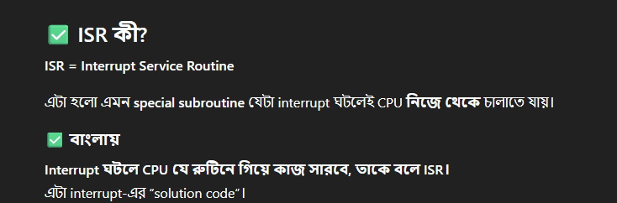
- Which scheduling is used in pipelines?
Dynamic instruction scheduling.
- Why out-of-order execution is useful?
It avoids stalls by reordering instructions.
- What is register renaming?
Technique to eliminate false dependencies.
- Why is CISC still used today?
For code density and legacy support.
- How does instruction latency differ from throughput?
Latency = time per instruction; throughput = instructions per unit time.
- What is speculative execution?
Executing instructions before branch resolution.
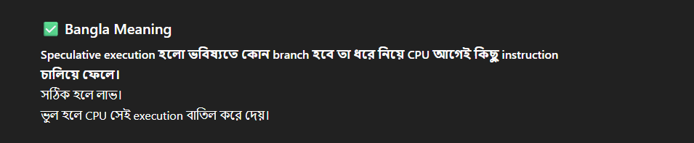
- Which register stores flags in 8086?
FLAGS register.
- Why is instruction pipelining limited?
Due to hazards and dependencies.
- What is difference between control and status signals?
Control directs operations; status shows current state.
- Why is DMA faster than CPU transfer?
It bypasses CPU for memory access.
- How does vectored interrupt differ from non-vectored?
Vectored has fixed ISR address; non-vectored needs external.
- What is shadow register?
Backup registers for fast context switching.
- Why prefetch buffer used?
To reduce memory access delay.
- What is pipeline flushing?
Clearing pipeline on wrong branch.
- Which flag detects arithmetic overflow?
OF flag.
- Why instruction length varies in CISC?
For flexibility and complex operations.
- What is stack frame?
Memory layout for procedure calls.
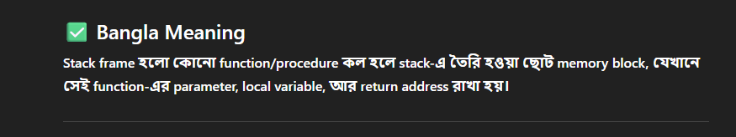
- Why call stack important?
It tracks active subroutine calls.
- How does priority interrupt work?
By assigning fixed priorities to requests.
- Which unit performs floating-point operations?
FPU (Floating-Point Unit).
- Why is microprocessor clock doubled internally?
To speed up instruction phases.
- How does pipeline stall resolved?
Using forwarding or bubbles.
- What is hyper-threading?
Simultaneous multi-threading for parallelism.
- Why instruction alignment important?
Misalignment causes extra cycles.
- What is watchdog timer?
A timer to detect system hangs.
- Why memory-mapped I/O used?
To unify I/O and memory address space.
- Which unit fetches instructions in pipeline?
Instruction Fetch Unit.
- Why cache associativity used?
To reduce conflict misses.
- What is difference between write-through and write-back cache?
Write-through updates memory immediately; write-back delays.
- Why hazard detection unit needed?
To avoid pipeline errors.
- How does clock skew affect CPU?
It causes synchronization issues.
- What is speculative branch execution?
Executing predicted branch path.
- Why loop unrolling used in assembly?
It reduces branch overhead.
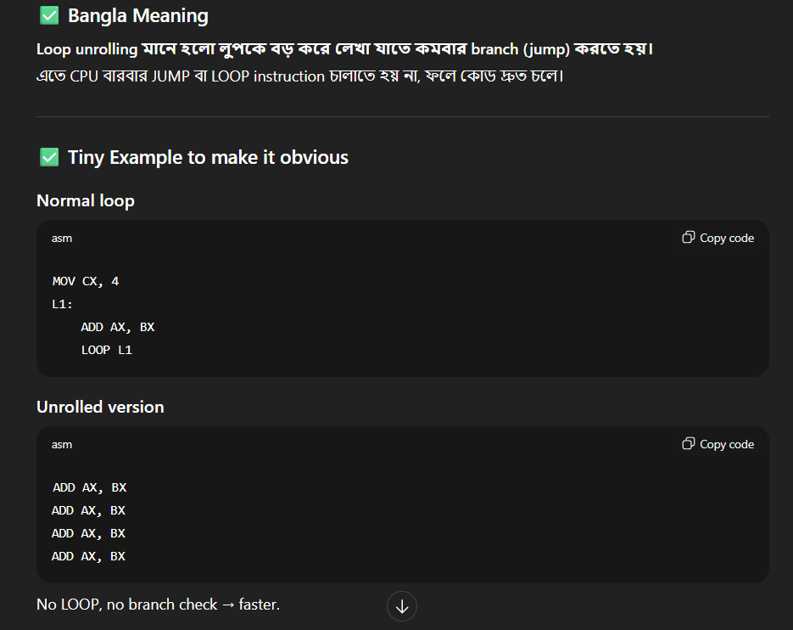
- What is instruction window?
A buffer holding decoded instructions.
- Why instruction set must be orthogonal?
For simplicity and consistency.

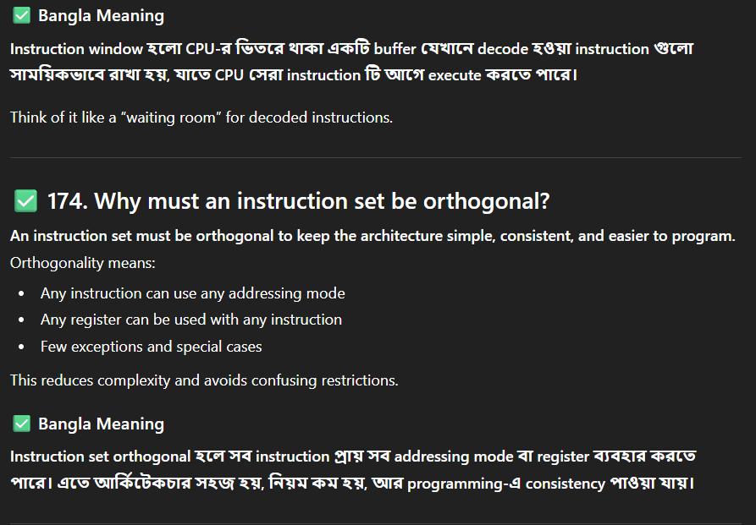
- What is micro-operation?
Small step implementing instruction execution.
- Why paging with TLB important?
It speeds up address translation.
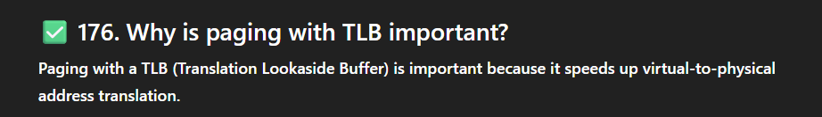
- What is bus arbitration?
Process of deciding bus master.
- Why priority inversion problem occurs?
When low-priority task blocks high-priority.
- How does cache miss penalty reduced?
Using multi-level caches.
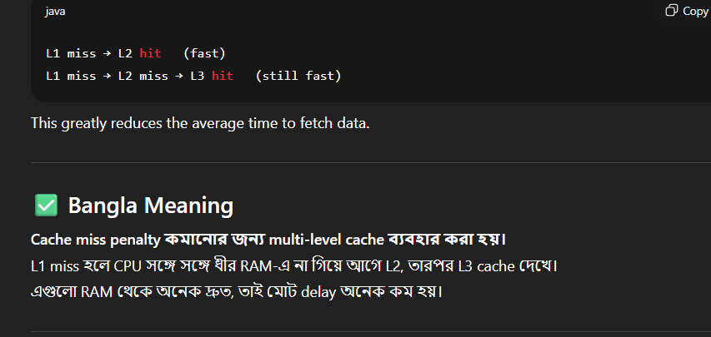
- What is difference between maskable and vectored interrupts?
Maskable can be disabled; vectored has predefined addresses.
- Why is instruction pre-decoding done?
To speed up later pipeline stages.
- What is barrel shifter?
A circuit for fast shifting/rotation.
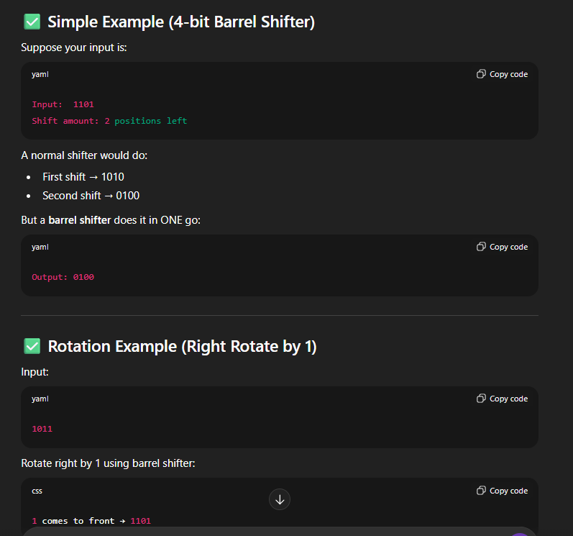
- Why instruction cycle differs from machine cycle?
Instruction cycle is multiple machine cycles.
- How does Harvard differ from Von Neumann?
Harvard separates memory; Von Neumann uses single.
- Why stack-based machines simpler?
They avoid explicit register addressing.
- What is pipeline depth?
Number of stages in pipeline.
- Why hazard forwarding used?
To solve data hazards quickly.
- What is branch delay slot?
Instruction executed after branch regardless.
- Why dynamic branch prediction better?
It adapts to program behavior.
- What is bus cycle?
One transfer operation over bus.
- Why instruction-level parallelism important?
It improves CPU throughput.
- What is superscalar execution?
Multiple pipelines execute instructions simultaneously.
- Why control word used in 8255?
To configure modes of operation.
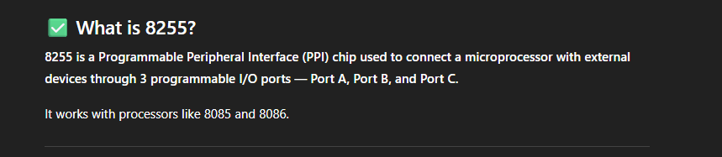
- What is tri-state buffer?
It has high, low, and high-impedance states.
- Why instruction profiling done?
To optimize performance hotspots. 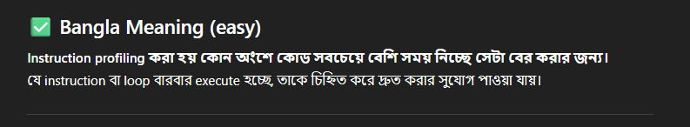
- How does hardwired control differ from microprogrammed?
Hardwired is fast but inflexible; microprogrammed is flexible.
- Why segmentation in memory beneficial?
It supports modular programs.
- What is paging overhead?
Extra time for address translation.
- Why wait states added?
For slow peripherals to sync.
- What is bus contention?
Conflict when devices drive same bus.
- Why stack pointer auto-decrements during PUSH?
To store data at lower memory addresses as stack grows downward.
- How does microprocessor handle recursive calls?
By using stack to save return addresses for each call.
- What is front-end and back-end of CPU pipeline?
Front-end fetches and decodes; back-end executes and writes results.
- Why instruction reordering is done by CPU?
To reduce stalls and improve execution efficiency.
- Which instructions are privileged in 8086?
Those that control system resources, like CLI and STI.
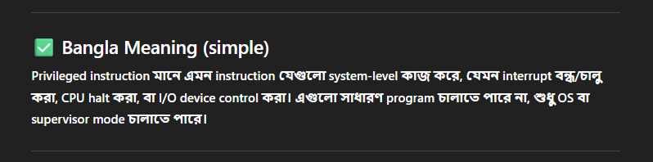
- Why instruction cache is smaller than main memory?
To provide faster access and reduce latency.
- What is context switch in microprocessor?
Saving and loading registers to switch between tasks.
- Why memory interleaving improves speed?
It allows parallel access to multiple memory banks.
- Which instruction sets include SIMD operations?
MMX, SSE, AVX in modern Intel processors.
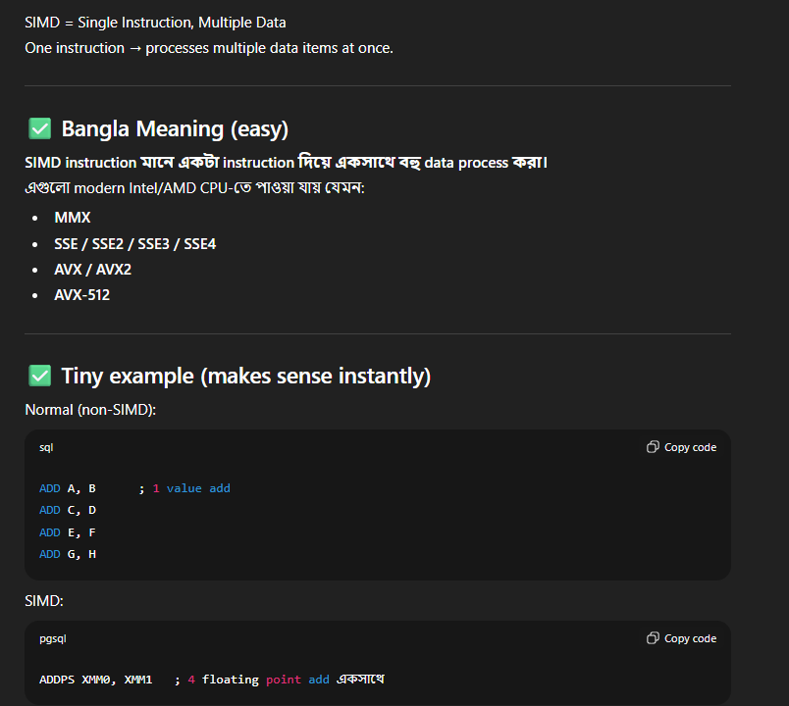
- Why does pipeline have hazards?
Due to instruction dependencies and branching.
- How is branch prediction implemented?
Using static (fixed) or dynamic (history-based) algorithms.
- What is reorder buffer in CPU?
It stores instructions executed out-of-order for correct commit.
- Why speculative load used in microprocessors?
To fetch data before confirmation, reducing stall cycles.
- Which instruction handles signed division in 8086?
IDIV instruction divides signed numbers.
- Why multiple clock domains in CPU?
To allow components to run at optimal frequencies.
- What is memory-mapped I/O advantage?
Same instructions can access both memory and I/O.
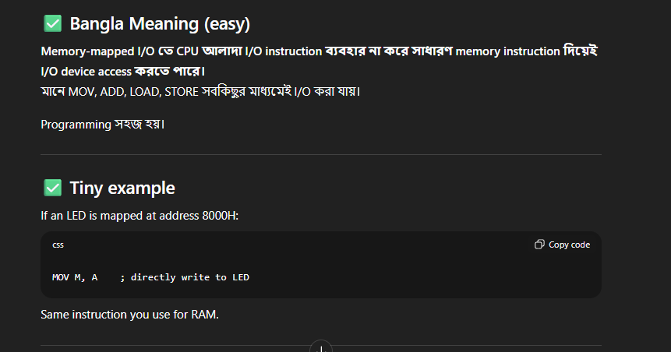
- How does branch target buffer work?
It caches addresses of recently taken branches.
- Why instruction decode stage critical?
Errors here affect entire execution pipeline.
- What is dual-ported memory?
Memory with two independent access ports for parallel read/write.
- Why instruction prefetch improves performance?
It reduces fetch delays by loading instructions in advance.
- What is write buffer in CPU?
Temporary storage for writes before updating main memory.
- Why is instruction scheduling important?
To minimize pipeline stalls and maximize throughput.
- Which instruction sets support bit manipulation?
8085/8086 includes ROL, ROR, SHL, SHR, BT, BTS, BTR.
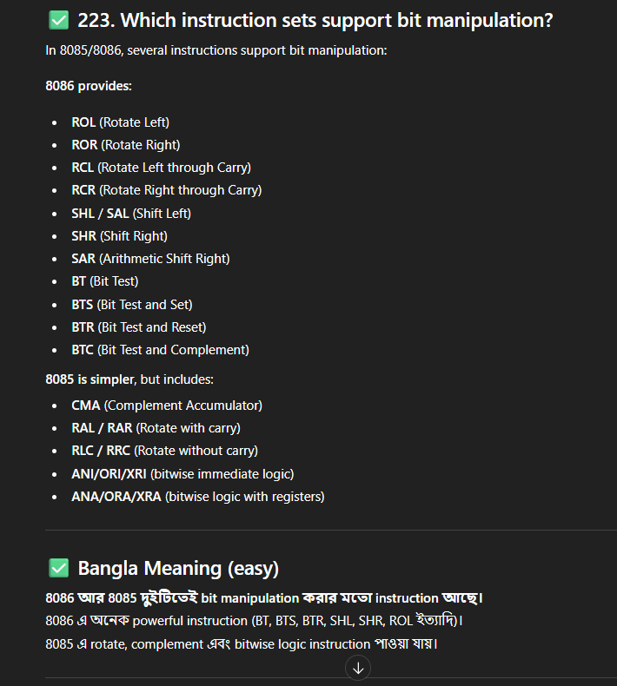
- How does hardware loop counter work?
Automatically decrements register and checks zero to control loops.
- Why CPU uses speculative execution?
To utilize idle pipeline stages and improve throughput.
- What is memory alignment?
Data stored at addresses divisible by its size for efficiency.
- Why cache line size matters?
It determines how much contiguous memory is fetched per access.
- Which instruction saves flags on stack?
PUSHF in 8086 saves all flag registers.
- Why instruction register important?
It holds current instruction being executed.
- What is dynamic voltage and frequency scaling (DVFS)?
Adjusts CPU speed and voltage for power efficiency.
- How does TLB improve virtual memory access?
It caches recent virtual-to-physical address translations.
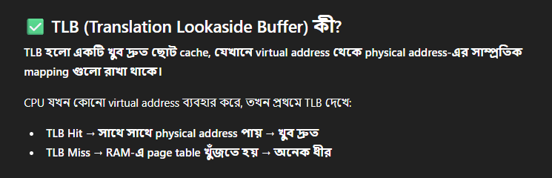
- Why branch misprediction costly?
Pipeline must flush and refill, wasting cycles.
- Which instruction repeats string operation?
REP, REPE, or REPNE.
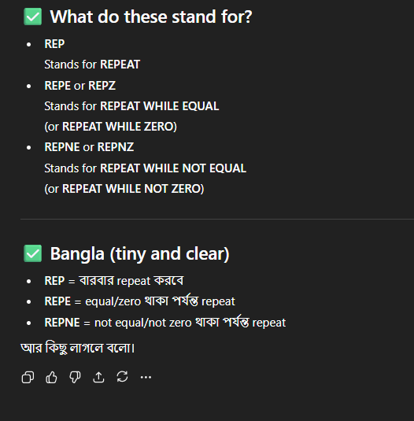
- What is priority encoder?
Selects highest-priority active input among multiple requests.
- Why stack grows downward in most processors?
To avoid overlapping with code and data segments.
- How does CPU handle nested interrupts?
By stacking return addresses and enabling priority-based servicing.
- Which instruction swaps bytes in a word?
XCHG can swap register contents; BSF/BTC used in bit-level.
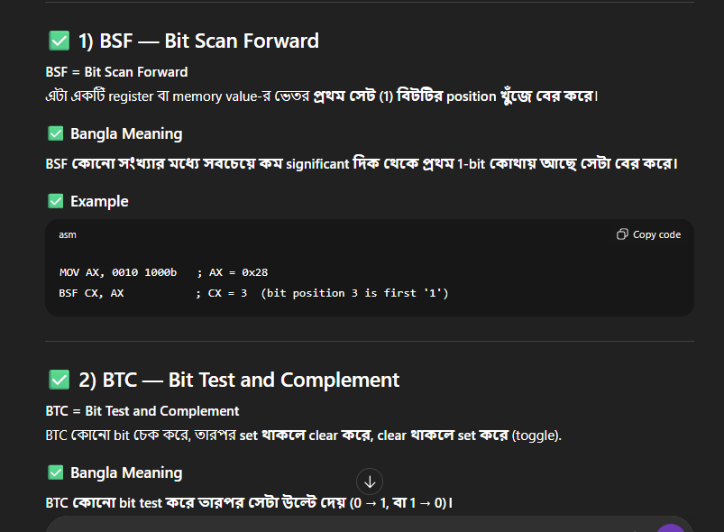
- Why control unit can be hardwired or microprogrammed?
Hardwired is faster; microprogrammed is flexible.
- What is difference between synchronous and asynchronous interrupts?
Synchronous occur with instruction execution; asynchronous by external events.
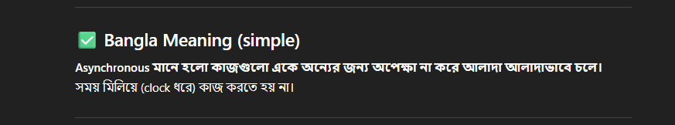
- How does instruction fusion improve performance?
Combines multiple instructions into a single micro-op.
- Why CPU uses multi-level caches?
To reduce latency and increase hit rate for memory accesses.
- What is branch folding?
Skipping execution of branch when outcome is already known.
- Which instructions support atomic operations?
XCHG, CMPXCHG, and LOCK-prefixed instructions.
- Why stack frame pointer used in debugging?
It helps trace local variables and procedure call history.
- How do superscalar pipelines handle multiple instructions?
By executing independent instructions simultaneously in parallel pipelines.

